Activity 9

Haden Stuart – has0027

3-tier:

* User interface:
* MainView class

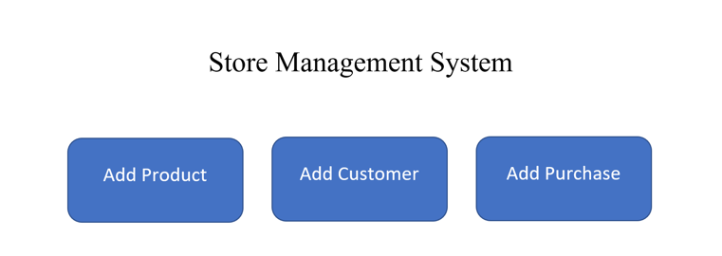

* AddProductView class

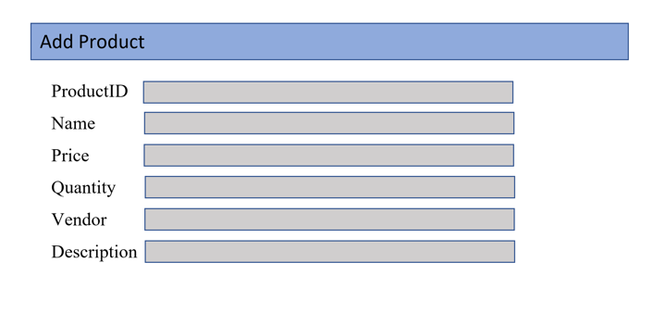

* Business logic:
* ProductModel class: store information of a product
* AddProductController: process events of AddProductView
* StoreManager: main application
* Data Access:
* SQLiteDataAdpater class: read/write data